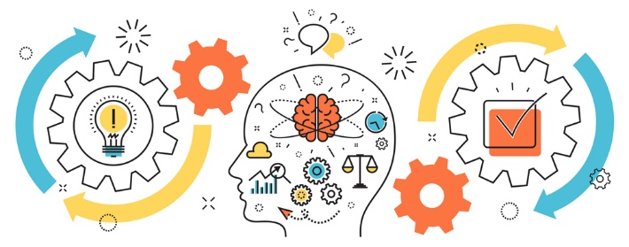
State of Kansas
Project Management
Class Offerings
PMI-ACP Exam Prep
November 12-14, 2024 8:30am-4:30pm Virtual
$1,250 per participant* PDU’s – 21

This three-day, fast paced boot camp prepares each participant with all the core competencies to pass the PMI-ACP® exam the first time. We teach you the terms, processes and skills to pass the course with minimal post course study. In addition, this course is based upon the PMI®- recommended reference materials on Agile, Scrum, XP, Lean, and other Agile approaches.
Objectives
- The Tools and Techniques and Knowledge and Skills areas to pass the exam
- The Tasks of Agile Principles and Mindset
- The Tasks of Value-driven Delivery
- The Tasks of Stakeholder Engagement
- The Tasks of Team Performance
- The Tasks of Adaptive Planning
- The Tasks of Problem Detection and Resolution
- The Tasks of Continuous Improvement
- The foundation of Agile, the Agile Manifesto and Principles
- Scrum roles, meetings, tools, techniques and artifacts
- XP (eXtreme Programming) roles and practices
- Lean development practices in Agile Project Management
- Agile estimation techniques
- Agile team dynamics, soft skills, negotiation, and coaching
- How Epics and User Stories are created
- Daily stand-ups, information radiators, team spaces, retrospectives, and osmotic communications

Registration: Please register through our KITO website:
https://ebit.ks.gov/kito/training. Once there please select the class you wish to attend, complete the form online and email to KITO@ks.gov. If you have any questions, please contact Celena Ramirez at 785-368-7161, or celena.m.ramirez@ks.gov.

Cancelation Policy: Cancelations up to 20 business days prior to class date are eligible for a 100% refund. Less than 20 business days there is NO refund.

The Mathis Group, Inc. is a Project Management Institute (PMI) Registered Global Educational Provider.
*2.5% administrative fee included
PMI’s Talent Triangle Breakdown for this class: Technical=14

