 |  |  |  | Information Technology Executive Council  Regular Meeting of the ITEC Board  MINUTES  September 22, 2022
The Regular Meeting of the ITEC Board was held on September 22, 2022, virtually using Microsoft Teams. This meeting was properly noticed and posted in the Kansas Public Square prior to the meeting. https://publicsquare.ks.gov/

Board Members:
Present unless otherwise noted

DeAngela Burns-Wallace, Executive Branch CITO |  | Erik Wisner, Non-Cabinet Agency Head #1
Kelly O'Brien, Judicial Branch CITO (Chair) |  | Lynn Retz, Non-Cabinet Agency Head #2
Alan Weis, Legislative Branch CITO |  | David Marshall, KCJIS
Rep. Emil Bergquist, House Representative #1 |  | Greg Gann, County Representative [Absent]
Rep. Pam Curtis, House Representative #2 |  | Mike Mayta, City Representative
Senator J.R. Claeys, Senate Representative #1 [Absent] |  | Duncan Friend, Information Network of Kansas (INK)
Senator Jeff Pittman, Senate Representative #2 |  | Steve Funk, Board of Regents
DeAngela Burns-Wallace, Cabinet Agency Head #1 |  | Judy Corzine, Private Sector Representative [Absent]
Amber Schultz, Cabinet Agency Head #2 [Absent] |  | Alex Wong, Chief Information Technology Architect

THIS MEETING IS IN COMPLIANCE WITH
KSA 75-7202 AND AMENDMENTS THERETO.

Public attendees, that signed in.

Bartron, Shelly [DA] | Heffel, Tanya, [OITS] | Role, Cole [OITS]
Butler, Daniels [OITS] | Hinton, Donnie [Legislature] | Sandberg, Andy [KDOR]
Denning, Allie [OITS] | Johnson, Shelia [OITS] | Theel, Eric [Legislature]
Spinks, Sara [OITS] | Ramirez, Celena [OITS]
OPENING CEREMONIES – CALL TO ORDER
Call to Order – CITO-J- Kelly O’Brien
Roll Call – Celena Ramirez

APPROVAL OF AGENDA

APPROVAL OF MINUTES
Minutes were accepted by CITO Kelly O’Brien

ADVISORY BOARD UPDATES/EDUCATION SEGMENT:
Information Technology Advisory Board (ITAB) Update DeAngela Burns-Wallace, CITO-E
CITO Burns-Wallace gave an update from the last ITAB meeting:
- The board spent the bulk of their time discussing ITEC policies and the updates of those policies.
- There was a general conversation on Cybersecurity about giving people resources that are available on that platform.
- We discussed the Executive Branch 3-Year IT Plan which is required by statute for submission on October 1st. The cabinet and non-cabinet agencies have already completed their plans.
- Sen. Pittman requested more information on what the standards by which Legislative Post Audit (LPA) are utilizing for IT security audits.
  - CITO Burns-Wallace replied that LPA controls their own guidelines for security audits and those of us who sit outside of that can provide feedback to them, but do not help to define or frame those guidelines. We invited LPA to join this meeting, but they were unable to. We plan to have them at the meeting in December.

ACTION ITEM REVIEW Alex Wong, CITA
The first action item was to determine IT Security Charter membership. CISO Jeff Maxon spoke with Kelly O’Brien and Alan Weis, and we have the information we need for the wording of the membership. This action item is closed.

PRESENTATIONS - DISCUSSION AND POSSIBLE ACTION
ITEC Policy Updates Alex Wong, CITA
- Policy 1100 – Software Licensing
- Policy 1500 – Software Code
- Policy 9500 – Wireless Local Area Network Policy
- Policy Series 2000 – Project Management
Significant process had been made for the two working groups, one for Policy 1100 & 1500 and the other for Policy 9500. We have actually finished up on the 1100 policy, and now moving towards building that standard which is in the new format that was adopted last year. The 9500 working group is responsible for wireless infrastructure. We are working on the same format which is the separate policy and standard format. Lastly, policy 2000 is coming to an end and we are ready for this group to look at the first draft of the policy. After the meeting we will send out a few documents to the group for any feedback.

Regents Presentation Steve Funk, Board of Regents
Steve Funk shared some applications that each University is procuring separately and how the Board of Regents is coordinating these efforts. The first one they are working on is a logging and monitoring system. In 2021, the Regents launched a project to investigate a consortium agreement for logging and monitoring. This would benefit all universities in the State. The next item we are working on is the upcoming Adobe renewal contract.

STAFF REPORTS - DISCUSSION AND POSSIBLE ACTION
Chief Information Technology Officer Updates
Judicial Branch Kelly O’Brien, CITO-J
CITO O’Brien reported that they are rolling out the case management system to all district courts in the State. As of September 11th, the case management system is in 100 courts. The only court they have left are the large courts such as Shawnee, Wyandotte, Douglas, and Johnson County. The Johnson County implementation is currently on a of different track. The other urban counties and the judicial building will be installed by next year. The next go-live will be this coming February, and they would like to have Shawnee, Douglas, and Wyandotte as part of the February go-live. Due to a substantial ransomware attack from four or five months ago, Wyandotte may not be ready to go-live with the new case management system. They will do the Appellate Court around April, and then work on Sedgwick County in June. They are in the process of finalizing Johnson County.

Executive Branch DeAngela Burns-Wallace, CITO-E
CITO Burns-Wallace reported that they are seeing many different projects being impacted by supply chain issues. Executive branch agencies continue to experience some staffing issues with losing staff in various ways, and challenges in recruiting. They are continuing to strengthen their service delivery such as with ServiceNow and the KITO process, etc. They are also working towards improving our security posture such as looking at our tools, resources, and relationships.

Legislative Branch Alan Weis, CITO-L
CITO Weis reported that the legislative interim is in progress, and there are many committees meeting at the Statehouse. We are continuing to use our WebEx video conference systems in the committee rooms through the interim period. The Joint Committee on Information Technology is meeting on Monday the 26th. The KLIS Modernization Project is underway and is in final negotiations with our vendor. The contract should be completed soon. The legislative staff computer refresh is near completion. Our legislative information systems are deployed and ready for the 2023 to 2024 legislative biennium and the 2023 budget legislative session will start Monday January 9th.

CISO Update Jeff Maxon, CISO
CISO Jeff Maxon reported that the Department of Homeland Security (DHS) and Federal Emergency Management Agency (FEMA) have released the notice of funding for the state and local cybersecurity grant program. The grant is going to require the state to develop a single cybersecurity plan for the state that incorporates all the jurisdictions. The funding is to help build a plan for that state, but also conduct an assessment of the state jurisdictions looking for gaps that future grant funding can be used to fill in those gaps. This will also have to go through the planning committee, which was passed last session. They planned to task the existing security council for that role and will start those meetings in the next few weeks. Mike Mayta asked about the funding process and whether the funding has been determined? Jeff Maxon replied that the process has not been determined yet. We have many activities planned for October which is Cybersecurity month. This is the fourth year we will hold a cybersecurity summit for the executive branch. The summit will be held in Wichita on October 25th. We are bringing in the Texas A&M extension school to conduct cyber training for the just the executives.

COMMENTS FROM BOARD MEMBERS
- Senator Pittman mentioned we have a Joint Committee on Information Technology that includes both Senate and House representative members that meets in the interim as well as during the session. We have series of meetings coming up in the next three months. When we have a change in administration, he is worried about what will happen to three year or five-year IT plans when we have a transition.
- CITO Burns-Wallace replied that the role Alex Wong as the Chief IT Architect is responsible for setting long term IT strategy vision and plan. He will soon be able to set up road map of what the state’s architecture across the next ten to fifteen years will look like and having that road map can help set some guard rails to ensure the transition of administration does not impact the IT long term plan.
- Mike Mayta mentioned regardless of who is at the helm, the need to address business requirements should not change based on who is in the governor’s office. You still have to serve the citizens. He would like to remind everyone that we share data across several sectors. He believed finding ways to open up and have better communications around planning and around opportunities is important.

NEW ACTION ITEM REVIEW Alex Wong, CITA
Alex listed the action items identified during the meeting:
- Contact LPA to have them present at the December 13th meeting.

CLOSING REMARKS
CITO O’Brien stated that CITA Alex Wong will be sending out copies of the policy 1100 after this meeting for feedback.

ADJOURNMENT
Adjourned at 2:32 p.m.

NOTE: Any individual with a disability may request accommodation in order to participate in committee meetings. Requests for accommodation should be made at least five working days in advance of the meeting.
ITEC BOARD MEMBERS


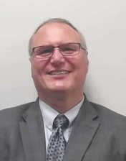
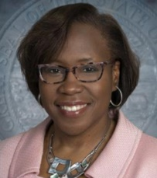
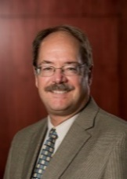

Alan Weis DeAngela Burns-Wallace, Chair Kelly O'Brien Steve Funk
Legislative Branch CITO Executive Branch CITO Judicial Branch CITO Board of Regents

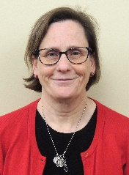
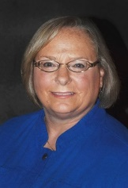

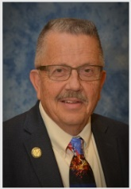

Lynn Retz Representative Email Bergquist Senator Jeff Pittman Representative Pam Curtis
Kansas Corporation Commission House Representative Senate Representative House Representative

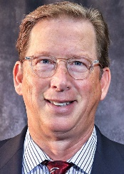
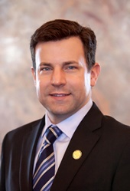
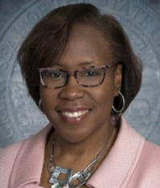
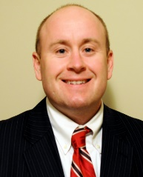

Senator J.R. Claeys DeAngela Burns-Wallace Erik Wisner Gregg Gann
House Representative Dept of Administration Real Estate Commission Sedgwick County

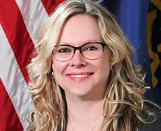

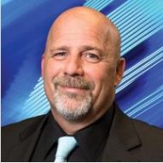
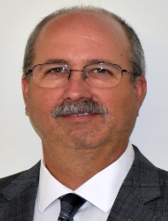

Mike Mayta Duncan Friend David Marshall Amber Schultz
City of Wichita Information Network of Kansas (INK) KS Criminal Justice Kansas Department of Labor

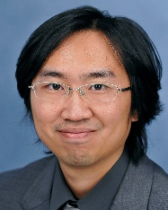
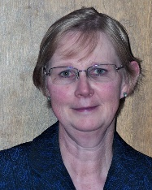

Judy Corzine Alex Wong
Private Sector Representative Office of Technology Services

