Kansas Information Security Office

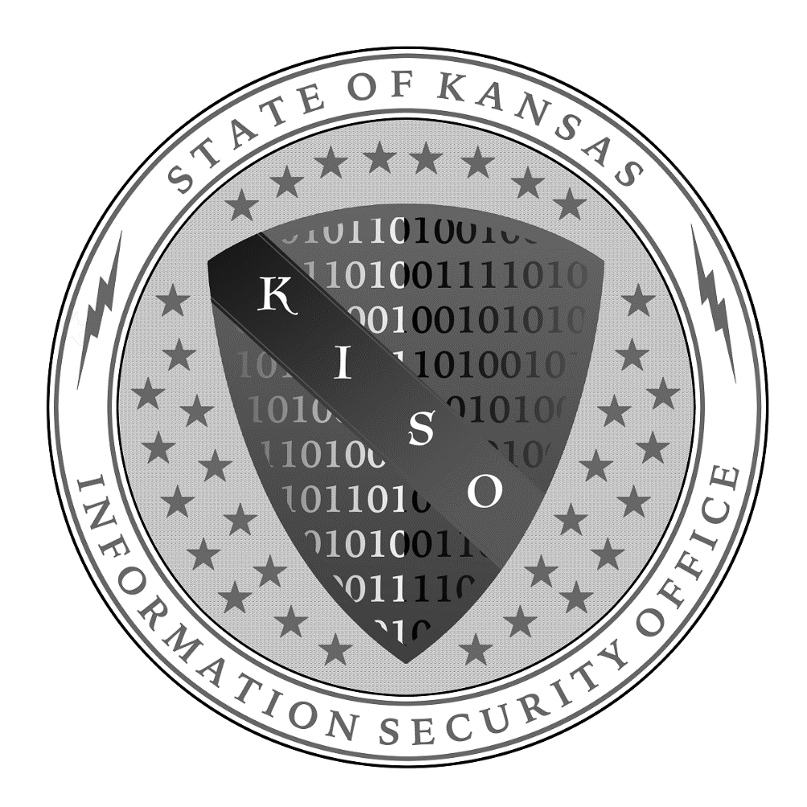

2019 Information Security Officer Guide
Created by
Jeff Maxon, CISSP, CISM
KISO Information Assurance Manager
Mark Abraham, CISSP
KISO Information Security Manager
Eric Smith, CISSP
KISO Information Security Officer
Vince Finney, CISSP
KISO Information Security Officer
Gary Scott
KISO Information Assurance Analyst
Contents
Forward: 3
Introduction 3
Tasks and Responsibilities 4
Information Security Policy Development and Maintenance: 4
System Inventory and Classification: 4
Information Security Risk Assessments: 5
Compliance Management: 9
Disaster Recovery (DR) and Continuity of Operations Planning (COOP) Assistance: 10
Incident Management and Response: 12
Configuration and Change Management: 13
System and Software Development Lifecycles: 13
Procurement Process: 14
Security Awareness Training: 14
Third Party and Contract Management: 15
Continuous Monitoring: 15
Organizational Self-Assessments: 16
Vulnerability Scanning: 16
Participation in KISO Sponsored Cybersecurity Initiatives and Services 17
Key Information Security Terms and Concepts: 18
KISO Resources Available Online 20
Recommended Readings and Resources: 20
Recommended Certifications: 21
References 22

Forward:
This document is intended to help individuals who have been appointed as their organization Information Security Officer (ISO) understand the basics of that role. This manual is not intended to be all encompassing but more of a desk resource. This guide follows the foundational functions of the ISO role found the Federal Government Chief Information Security Officer Handbook and the Commonwealth of Virginia’s ISO Manual. We extend our thanks for the hard work that was put into those documents as they have served as valuable resources.

Introduction
Information Security is a major concern for all organizations. In 2018, The State of Kansas took a proactive step to help ensure an improved state of cybersecurity throughout the executive branch by signing into law the Kansas Cybersecurity Act (KCA). The KCA has many important provisions. However, the most notable are the requirements that every executive branch organization establishes an information security program and appoints an Information Security Officer (ISO).
Information security is the process to protect the creation, collection, storage, use, transmission, and disposal of information. Information security promotes the commonly accepted objectives of confidentiality, integrity, and availability of information.
Confidentiality: Ensuring information can only be seen by authorized individuals.
Integrity: Ensuring information is reliable, accurate, and free from modifications by unauthorized individuals.
Availability: Ensuring information is accessible when needed
An organizational information security program will incorporate and implement various managerial, operational, technical, physical and administrative controls to reduce or mitigate risks to the organization’s information assets and ensure their confidentiality, integrity and availability.
An Information Security Officer (ISO) is the individual assigned responsibility for developing and maintaining the organization’s information security posture and program. This is achieved through various activities such as developing organizational information security policies and procedures or ensuring compliance and being a trusted advisor for the organization by assisting with strategies to mitigate risks to the organization, its data, and information systems.
Information security starts with the “Tone at the Top” which is why the KCA places responsibility for the organization’s information security program and culture with the Agency Head. ISOs, to be effective, must have a good working relationship with the organization’s head. Information security should not be relegated to just IT or an information technology function. Information security is an organizational activity and should incorporate aspects from all departments including management, HR, legal, and the various organizational business units.
Information security can get very complex and become overwhelming very quickly. An ISO must follow the principle of Keep Information Security Simple (K.I.S.S). As an ISO, information security is your focus, you will be working with people who do not think about it day in and day out. You will introduce subjects they are not familiar with or they haven’t even thought about, and at times, you may overload them with information; do your best to Keep Information Security Simple.

Tasks and Responsibilities
As the ISO, you will serve as your organizations trusted advisor on matters regarding information security and information risk management. In order to be successful, you must develop a relationship with the organization head and senior management. You will also be tasked with establishing the organization information security program. You will do this through various tasks and responsibilities.

Information Security Policy Development and Maintenance:
Information security policies, procedures, and standards are the foundation to any information security program. All state agencies and organizations, at a minimum, are required to follow the State of Kansas Information Technology Executive Council (ITEC) 7230 Information Security Policy and its standards document 7230a. However, an organization may want to have more specific policies that are more restrictive than what is required by ITEC. If an organization must comply with any federal requirements, ITEC in most cases, does not meet federal compliance requirements. As the ISO, you are responsible for the organization’s information security policies, and the determination of compliance requirements for securing organization data, process, and services. Once you understand the requirements you can begin creating the organization’s security policies. Policies should be created with the help of the business units. Work with them to craft language and seek their feedback. Additionally, policies must be signed and approved by the organization’s head. Policies should be reviewed annually and updated every three years. Procedures should be reviewed and updated at least annually.
There will always be exceptions to policies and procedures. When there is an exception to a policy, there is generally some risk associated with each exception. As the ISO, it is your job to document any and all exceptions to policy, make sure organization management and executives are aware of the exceptions and the risks they present. Finally, ensure the organization’s executive acknowledges and accepts the risk incurred by the exception.

System Inventory and Classification:
To help an organization with an information security program, you need to know what they have and what needs to be protected. A system inventory and classification or discovery is an important step to developing a security program. You need to know what information systems your organization has, what business processes they support, their ownership, what type of data is in the system, and basics about its architecture. Once identified and classified, you can begin to develop a comprehensive program for each of the information systems and their business processes.
There are several key security roles and responsibilities for a comprehensive information security program. All information systems should have these specific roles identified. If they do not, make sure they are identified and that they understand their role and responsibilities to ensure information security. (Note: For smaller organizations, it is likely that many of these roles will belong to one staff member and is therefore not uncommon.)
Data Owner: Agency head or a member of upper management who is in charge of the business unit that collects and utilizes the information or information system. The data owner is ultimately held responsible for the protection of the information or information system.
Data Custodian: Group or individual responsible for maintaining and protecting the data. Typically, this is an IT role.
System/Application Owner: Manager of the primary business unit that utilizes the information system
System Administrator: Individual or group responsible for day to day administration of the IT systems and implements the requirements of the IT security program.
Account Administrator: Individual or group responsible for user access and permissions within the application or system.
Privacy Officer: Individual who can provide guidance and knowledge on privacy laws and regulations as they apply to organization information. The State of Kansas does not require a privacy officer for all organizations. However, there are other regulations that may require a privacy officer such as HIPAA for covered entities.

Information Security Risk Assessments:
As the ISO, you will be conducting risk assessments. Risk assessments should be conducted at the organizational level and for each information system. At the heart, a risk assessment identifies vulnerabilities and threats to an organization, information system, or even a business process, determines their likeliness of occurrence and what their potential impact would be to the organization if exploited. The National Institute of Standards and Technology outlines the following steps for conducting a risk assessment in Special Publication 800-30 Rev. 1 “Guide for Conducting Risk Assessments”:
- System Characterization: Identify boundaries of the system and the components that make up the system. This helps establish the scope of the assessment.

- Threat Identification: Identify any potentials to exploit a vulnerability. Threats exist when a threat-source, human, natural, or environment can exploit a vulnerability. Human threat sources must also have a motivation to exploit the vulnerability. Example: a hacker (Threat Source) hopes to make a political statement (Motivation) and hacks (Threat) into a website by exploiting a vulnerability to deface it.
- Vulnerability Identification: Identify any flaws or weakness in the system or environment that can be exploited intentionally or accidently and cause undesirable results. Vulnerabilities can exist in system procedures, processes, components, application code, system design etc.

- Control Analysis: Identify controls, either planned or in place, that can reduce the potential of a threat exploiting a vulnerability.
- Likelihood Determination: Determine the probability that a vulnerability will be exploited by a threat-source. Controls may have been identified that reduce the likelihood.
Table 1 NIST SP 800-30 Rev.1 Likelihood Definitions
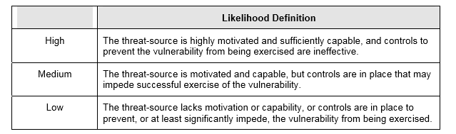
- Impact Analysis: Determine the magnitude of the adverse impact from the exploitation of a vulnerability. The impact is any loss of one or a combination of, confidentiality, integrity, or availability. Controls may have been identified that reduce the impact.
Table 2 NIST SP 800-30 Rev.1 Impact Definition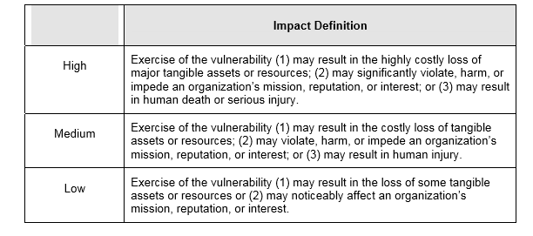
- Risk Determination: Overall risk is determined by the likelihood and the impact of a vulnerability being exploited.
Table 3NIST SP 800-30 Rev.1 Risk-Level Matric
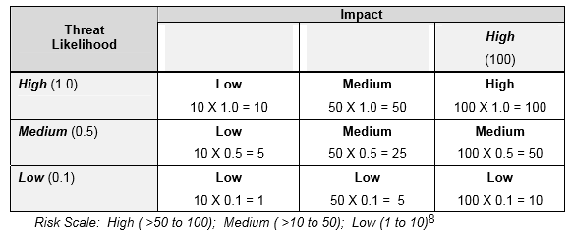
Table 4NIST SP 800-30 Rev.1 Risk Scale and Necessary Actions
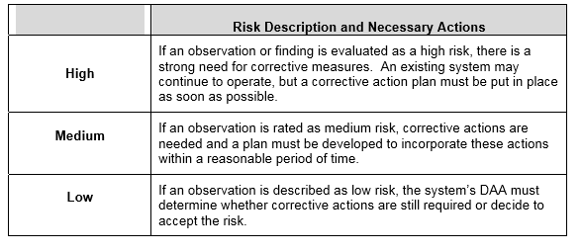
- Control Recommendations: New controls that could help mitigate risks should be identified and recommended for implementation.

- Results Documentation: Create a formal report of the risk assessment and provide it to organizational managements
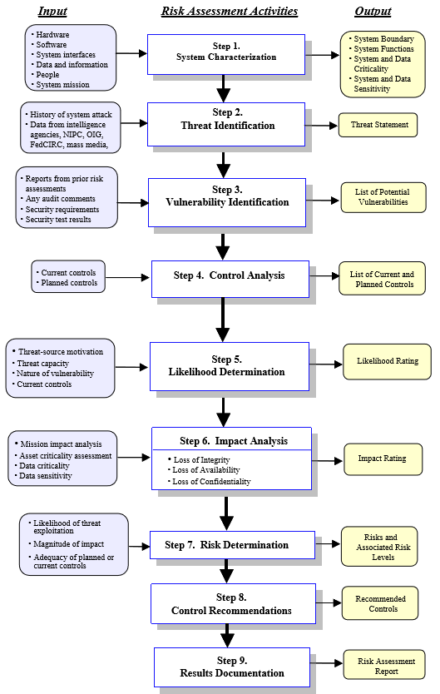
Risk Assessment Methodology from NIST SP 800-30 Rev.1
Like most areas of information security, senior management must be involved in the risk assessment process. Be sure to include such individuals as the data owner, data custodian, system owner, and system administrators. The risk assessment is a collaborative process and input from all aspects of the information system and business processes should be considered or discussed. Recommendations to mitigate risks can be identified and documented during the risk assessment process.
Typically, a risk assessment should be completed every three years or when a significant change occurs within the information system or business process. Once the assessment is complete, it must be shared with organizational leadership. Organizational leadership needs to be made aware of risks that the agency or organization is exposed to. Organizations should have a risk management process or committee that handles, and addresses identified risks to the entire organization. Recommendations to mitigate risks can be identified and documented during the risk assessment process.

Compliance Management:
Most organizations are subject to regulatory compliance requirements. These compliance requirements may come from state policies or, statutes, federal regulations or laws. Other compliance requirements are inherited from external entities that share information with state agencies. Some examples of compliance requirements include ITEC, HIPAA, FTI, CJIS, PCI, SSA among others. The ISO should work to ensure the agency is meeting both technical and nontechnical requirements; key to ensuring compliance among data shared with other organizations is a data sharing agreement that addresses information security compliance requirements.
Many organizations undergo compliance audits to verify requirements are being met. During these engagements, the ISO should be the primary contact for auditors to assist in any compliance audits of the agency. The ISO role in assisting in audits may vary. The ISO could facilitate the audit and auditors, collect documents and evidence, and assist with answering auditor’s questions. If the ISO cannot answer the questions, they should be able to coordinate with the responsible party to answer the questions. Additionally, the ISO may be responsible for responding to any findings and may work to close the findings as they are discovered.
It is important to understand, that auditors are not adversarial to organizations and their information security programs. Audits and auditors can be very helpful in furthering and bettering information security programs. Try to prepare in advance for each audit and identify and collect artifacts prior to the audit. Be open and honest with the auditors. Most auditors can tell when you are trying to misrepresent information so, if you have a shortcoming, admit it and continue moving forward with the audit. The smoother the audit goes, the less time the auditors will spend reviewing your agency. The auditors will provide a report of the findings, which in turn makes a great list of tasks that can enhance your program. Additionally, the audit and report can provide you with data to potentially secure additional resources from organization executives to further the program. Audits should be thought of as a tool of the program and not something to avoid or dread.

Disaster Recovery (DR) and Continuity of Operations Planning (COOP) Assistance:
No entity wants to suffer a disaster or have their information systems down. The reality of it is that computers are pieces of equipment that can fail and crash. Various other disasters, manmade, natural, or cyber can occur within a localized or broad area. As a governmental entity, our survival isn’t based on how we respond to those scenarios. However, the citizens we serve depend on our services and they need them available in a timely fashion. In many instances, the services we provide as a state are critical to them whether meeting basic needs or affecting their livelihoods.
Disaster recovery planning is a focused restorative effort aimed at specific systems and business processes while in the midst of a disaster. A Continuity of Operations Plan or (COOP) is much broader concept and can contain multiple disaster recovery plans and physical relocation strategies to continue operation in the midst of a widespread disaster or outage and what needs to be done to return to normal operations. As the ISO, you play in important role. Availability is one of the three pillars of information security. As discussed above, there is a great reason why availability is so important. Ensuring organizations can survive critical system failures and disasters is imperative. No organization is immune to disasters whether natural, manmade or cyber related. The ISO will need to work with system owners and business owners to ensure that disaster recovery plans have been created, tested and exercised. If plans have not been created, you may need to engage and facilitate activities focused on creating those DR plans and COOP.
NIST SP 800-34 Revision 1 “Contingency Planning Guide for Federal Information Systems” outlines a seven-step process for contingency planning for a system.
- Develop the Contingency Planning Policy Statement: Each organization should have a contingency planning policy that directs organization roles and responsibilities, scope of contingency plans, training, exercise requirements, plan maintenance and a backup schedule.

- Conduct the Business Impact Analysis (BIA): The BIA documents the damage that a disruption would cause to an organization or business process that utilizes certain information systems. The BIA should document the business units Maximum Tolerable Downtime, Recovery Time Objective, and Recovery Point Objective for the information system.

- Identify Preventative Controls: Identifying preventative controls falls inline with implementing the Risk Management Framework. There are physical controls such as generators and battery backup that may reduce some of the impact to an organization in the time of a disaster. Identify such control in this step.

- Create Contingency Strategies: During this step, you should look at attempting to identify things such as backup strategies, data storage locations, backup retention schedules, and avenues to procure equipment.

- Develop a Contingency Plan: A contingency plan is made up of five main components and three phases. The activation and notification phase, recovery phase, and reconstitution phase. Directions in the plan should be to the point, easy to follow and clear. If at all possible, they also should be written so someone with little background or limited familiarity could implement the plan in an emergency situation.
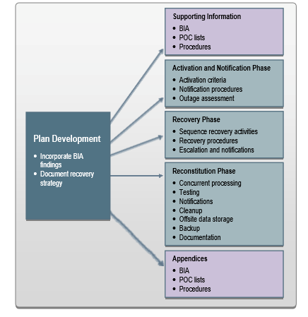
Contingency Plan Structure from NIST SP 800-34 Revision 1
- Plan Testing, Training, and Exercises: An effective plan is one that has been tested and exercised to ensure that the steps in the plan are valid. Testing could be everything from a tabletop exercise to a full-blown exercise and should be conducted on a regular basis. Lessons learned from exercises and training should be incorporated into the plans.
- Plan Maintenance: Contingency plans, whether a DR plan or a COOP plan are living documents and should not become stagnant. Contact information should regularly be validated and updated. The plan should also be reviewed and updated anytime major system changes occur. If events don’t generate the review a regular review cadence should also be followed.

Incident Management and Response:
The unfortunate reality is that everyone will experience some sort of information security incident. That said, organizations need to be prepared to handle incidents as they occur. How you respond to the incident determines its overall impact to the organization. As the ISO you may be asked to help respond to a variety of security incidents that could range from a compromised account to a large-scale data breach. We must be able to respond accordingly.
There are several stages to incident response. NIST Special Publication 800-61 Revision 2 Computer Security Incident Handling Guide outlines those stages.
- Preparation: Organization’s must be prepared to respond to an incident. Organizations are bombarded with all sorts of different attacks and all sorts of incidents. There is no way to prepare for every type of incident or attack. One of the first things that needs to be done is to establish an incident response team and have ways to get in touch with them both during and after business hours. The response team will be made up of members from different areas. Some members that should be on the team include legal, public relations, server administrators, workstation administrators, network administrator, security analyst, and a team lead. There is no perfect team make up. Also, if your organization does not have these types of resources, you will need to make sure you know who to contact to get help in supporting your entity during an incident. The KISO is an example of a resource you should have documented to reach out to.
- Detection and Analysis: There are multiple ways to detect an incident: system alerts, log analysis, user reporting, security device alerts, and many others. Part of the analysis will be determining the legitimacy of the event whether it is an incident or a false positive. If the event is deemed an incident, the scope of the incident will need to be assessed. Also, during this stage after an incident has been determined, notification should be made to appropriate staff and stake holders. A communications plan during incident response is critical.
- Containment, Eradication, and Recovery: After an incident has been declared and initial triage has taken place, efforts should be taken to contain the incident and prevent it from growing. Once contained, things such as malware or compromised accounts will need to be remediated. Additionally, if vulnerabilities were exploited, these should be identified and remediated as well. Once eradication is believed to be complete, organizations should move into restoring and recovering to normal operations. The steps of “Detection and Analysis” and “Containment, Eradication, and Recovery” may be cyclical in nature and new infections or incidents may be discovered during the process as it moves forward.
- Post-Incident Activity: After an incident, the organization should ensure a lessons learned document or after action report is created to detail the incident and its response. Organizations should incorporate things that worked into their existing plans and document what didn’t work, why it failed, and either look to improve it or remove it in their plan. They should also use the post-incident activity to identify gaps in both processes and resources that would have helped address the incident.
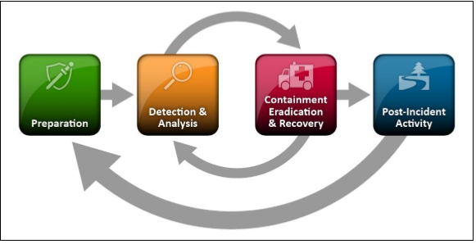
Incident Response Lifecycle from NIST SP 800-61 Revision 2

Configuration and Change Management:
Many policies and data sharing partners require that organizations develop, document, and implement baseline configurations for information systems. Additionally, organizations must document changes to their information systems and ensure that those changes don’t negatively impact information security. While it may seem trivial at times, organizations should document the changes and communicate those changes to relevant stakeholders. As the ISO, you need to be aware of those changes and the potential impact the changes may have on security.

System and Software Development Lifecycles:
In the past, information security was an after thought during system and software development lifecycles. As the organization ISO, you will need to ensure that information security is injected at the beginning of projects and integrated throughout the entirety of the project’s lifecycle.
System lifecycles follow five phases:
- Initiation: The organization establishes the need for a system and documents its purpose. Security planning should begin in the initiation phase with the identification of key security roles to be carried out in the development of the system

- Acquisition/development: The system is designed, purchased, programed, developed, or otherwise constructed. A key security activity in this phase is conducting a risk assessment and using the results to supplement the baseline security controls

- Implementation: The organization configures and enables system security features, tests the functionality of the security features, installs or implements the system and obtains a formal authorization to operate the system

- Operational maintenance: Systems and products are in place and operating. Enhancements and/or modifications to the system are developed and tested. Hardware and software components may be added, replace, or updated. Tests should be conducted to ensure that none of the changes negatively impact security

- Disposal: Systems are decommissioned from service and disposed of. Information should be archived, transitioned to a new system, destroyed, or any combination of. Data not disposed of properly can result in unauthorized disclosure of sensitive data.
Software development lifecycles are very similar to system lifecycles but include steps for requirements gathering, design, development, testing/validation, and release/maintenance. The software development lifecycle may fall into the larger aspects of a system development lifecycle.

Procurement Process:
Information security needs to also be addressed during the procurement and contracting processes. Regardless of the bidding process, be it Request for Proposals (RFP), Request for Information (RFI), Request of Quote (RFQ), or contract information security needs to be included in the process. Examples of topics included in the contracting process are;
- Data protection requirements
- Right to audit clause
- Breach notification and handling
- Subcontractor utilization
- Off shoring of IT resources
- Data destruction/sanitization requirements
- Identification of any additional outside requirements such as those from federal partners
The contracting process sets the tone for information security as a priority to the organization when working with vendors. If there are any questions regarding contract language or language to include in the RFP, RFI, or RFQ process, do not hesitate to ask the KISO.

Security Awareness Training:
Information security is everyone’s responsibility not just within information technology. An organization’s staff is both the first and last line of defense for information security. As the ISO, you are responsible to ensure that your organization has access to security awareness training material. Refer to ITEC 7230a for the State of Kansas annual security awareness training requirements. Also, be sure to include any additional regulatory required security awareness training.
The pinnacle of information security is a culture of security awareness, where information security is woven into all aspects of the business. A goal for the ISO is to foster a security aware culture. This can be accomplished through numerous avenues. First, security awareness training. Secondly, regular reminders of information security tips and practices that helps to reinforce employees existing knowledge. Incorporating the information learned can valuable to employees both at home and work. If employees can apply things to their personal life, they will be likely to apply them at work and make it a habit.
The KISO currently provides a security awareness training tool to deliver general security awareness training. In addition to general security awareness training, the tool provides role-based and compliance-based security awareness training content. The tool can also provide a phishing simulator that can launch simulated phishing campaigns against enrolled users.

Third Party and Contract Management:
Organizations are becoming increasingly dependent on contractors and service providers. Contractors and Service Providers may do everything from build applications, host applications, to helping the business carry out core functions. As the ISO, you will need to help the business unit safeguard their information when it is in possession of a contractor, vendor, or service provider. This can be accomplished with several controls. First, you will need to make sure that there is language in the contract that requires the contractor, vendor, or service provider to meet the organization’s and State of Kansas’ information security requirements. Any additional information security or compliance requirements such as state statutes, federal rules, laws, or regulations must be included. Sample contract language may be found on the KISO website. The ISO may also need to assist in validating that the contractors, vendors, and service providers are complying with the information security requirements in the contract and the organization security policies.

Continuous Monitoring:
NIST defines “Continuous Monitoring” in SP 800-137 Information Security Continuous Monitoring (ISCM) for Federal Information Systems and Organizations as “maintaining ongoing awareness of information security, vulnerabilities, and threats to support organizational risk management decisions.” Continuous monitoring involves six steps:
- Define: Help define a strategy that aligns with organization and business unit risk tolerances.
- Establish: Metrics and monitoring frequencies for controls, architecture, vulnerabilities and threat information
- Implement: Collect information to address the metrics.
- Analyze and Report: Assess collected data and report to develop a response
- Respond: Implement appropriate controls, managerial, operation, or technical based on the mitigation strategy, avoid, transfer, accept
- Review and update: Follow a continuous improvement model looking for ways to improve monitoring and awareness capabilities

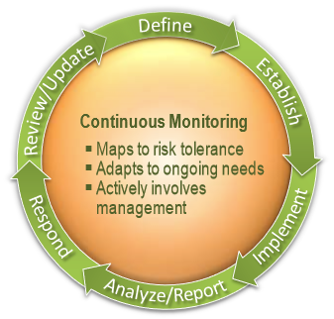
Continuous Monitoring from NIST SP 800-137
ISO’s are responsible for working with the organizations and their data owners to develop a continuous monitoring plan for their information systems.

Organizational Self-Assessments:
Information security is a program and a process. It constantly needs to be evaluated to determine where there is growth and shortcomings that need to be addressed. As the ISO you will need to ensure that you are conducting your own mini audits of your organization security program. Not only is this a great practice, it is required by law in the recently passed Kansas Cybersecurity Act. It is highly encouraged to use a capability maturity model to measure the maturity of your program against at a minimum the State of Kansas Information Security Policy ITEC 7230 and its standards document 7230a. The KISO has provided a Self-Assessment template for the purpose of fulfilling this requirement on its website. See the KISO resources section at the bottom of this document for a link.

Vulnerability Scanning:
Vulnerability scanning is an important information security tool. System and application vulnerabilities can be exploited allowing an attacker to manipulate systems to do things they aren’t supposed to do. A vulnerability scanner will look at systems and many of the commercial applications on them, and let you know if they contain known vulnerabilities and the criticality of the vulnerabilities. New vulnerabilities are constantly being discovered. Vulnerability scanners should be regularly updated to be able to scan for those new vulnerabilities. Vulnerability scanning should be conducted on a regular basis. The KISO provides vulnerability scanning services. Organizations must patch discovered vulnerabilities to reduce their attack surface and the potential of the vulnerabilities being exploited for malicious purposes. ISOs must ensure technology departments have documented patching process and procedures. These processes and procedures should be validated with reportable metrics that are reviewed on at least a monthly basis.

Participation in KISO Sponsored Cybersecurity Initiatives and Services
Executive branch agencies subject to the KCA are required to participate in cybersecurity initiatives and services offered by the KISO. However, these initiatives an services are also available to all other agencies to include both the Legislative and Judicial branches of government. A list of KISO provide services is below.
In addition to services, the KISO will periodically sponsor targeted cybersecurity events tailored for specific organizational roles. The events will be focused on increasing awareness of information security issues, topics, and trends.
- Enterprise Security Services (ESS) – these services are included within the OITS “Node” or “Router” rate, they are available to all organizations connecting to the State enterprise data network (KANWIN).
- SLA-Based Managed Security Services (MSS) – Under the MSS ‘umbrella’, two cybersecurity contract services are available, they are Technical Security Services (TSS) and Information Security Officer (ISO) services.
- Other – Ad Hoc cybersecurity services
 |  | MSS
Service | ESS | TSS Services | ISO Services | Other Services
Cybersecurity Awareness Training | X
External Cybersecurity Scoring | X
Cyber Hygiene Scoring | X
Internet Firewall Administration | X
Internet Intrusion Prevention | X
Website Filtering | X
Application Filtering | X
24x7 Internet Security Monitoring | X
Security Information and Event Mgmt. (SIEM) | X
Website Certificates | X
Intelligent Central Logging | X
Application Firewalls | X
Load Balancing | X
Virtual Private Networking (VPN) | X
Host Vulnerability Scanning | X
Application Vulnerability Scanning | X
Behavioral Analytics | X
Secure Virtual Access for Vendors and Contractors | X
Advanced Email Filtering | X
Continuous Monitoring | X | X | X
Custom Website Filtering |  | X
Custom Application Filtering |  | X
Local Security Control Administration (FWs, IPS, etc.) |  | X
Custom Reporting |  | X | X
Compliance Management |  | X | X
Governance |  |  | X
Contract Security Compliance Review |  |  | X
Project Security Compliance |  |  | X
Risk and Security Assessments |  |  | X
Incident Response Development |  |  | X
Custom Cybersecurity Training |  |  | X | X
Cybersecurity Consulting |  | X | X | X
Dedicated Security Staff |  |  |  | X
Table 5: KISO Services

Key Information Security Terms and Concepts:
Vulnerability: A weakness or flaw can be exploited. Vulnerabilities can exist in software, hardware, procedures, or even human weakness.
Threat: The danger of a vulnerability being exploited.
Risk: The probability of a vulnerability being exploited and the potential or associated impact.
Exposure: When vulnerabilities are present and expose an entity to a threat.
Control: A countermeasure or safeguard put in place to reduce risk or eliminate a vulnerability. There are three control types, administrative/managerial, operation and technical.
Risk Management: An approach to identify risks and their impact to an organization and to reduce the level of risk or residual risk to an acceptable level through various means. There are several strategies to handle risk:
Risk Mitigation: Applying an administrative/managerial, operation and technical or control to reduce the level of risk incurred by the threat/vulnerability
Risk Transference: Transferring the risk to another entity or organization (Insurance)
Risk Acceptance: Organization leadership feels damaged caused the risk is one that they are willing to accept and they will not wish to apply any other type of risk management to
Risk Avoidance: Activity, process, or system that creates or presents the risk is stopped in order to prevent its exploitation
Plan of Action and Milestones: A document that is used to track open risks, vulnerabilities, or audit findings to track, prioritize and monitor progress of efforts to close those risks, findings or weaknesses etc.
Maximum Tolerable Downtime (MTD): The maximum time an information system can be down before an organization begins suffering unacceptable consequences.
Recovery Time Objective (RTO): Is the timeframe after a system fails that an organization hopes to have it restored by.
Recovery Point Objective (RPO): Is the timeframe of lost data that is acceptable an agency. When was the last backup up before an incident?
Defense-in-depth: An information security strategy where controls are layered on top of each other to protect the organization’s assets from threats.
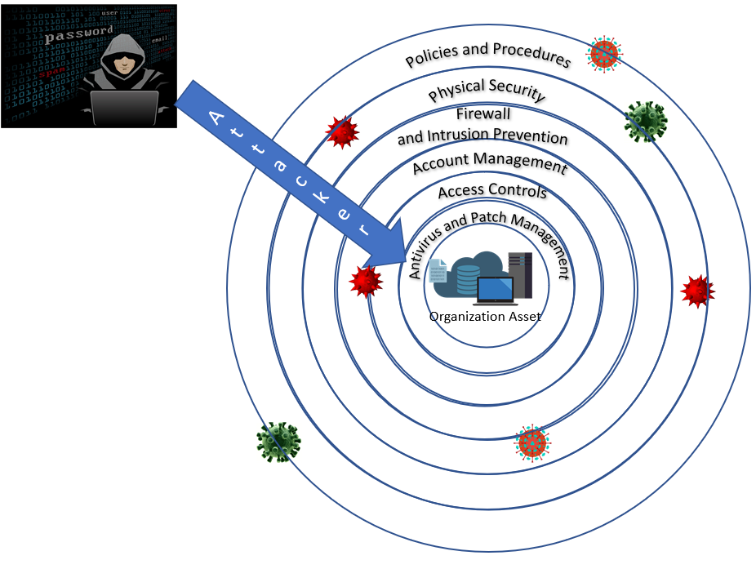

KISO Resources Available Online
https://oits.ks.gov/info-security/assurance-and-compliance-resources

Recommended Readings and Resources:
Shon Harris’s All in One CISSP Exam Guide Sixth Edition
National Institute of Standards and Technology Special Publication 800-53 Revision 4
Security and Privacy Controls for Federal Information Systems and Organization
https://nvlpubs.nist.gov/nistpubs/SpecialPublications/NIST.SP.800-53r4.pdf
National Institute of Standards and Technology Cybersecurity Framework
https://www.nist.gov/cyberframework
Center for Internet Security (CIS) Critical Top 20 Security Controls
https://www.cisecurity.org/controls/
Cloud Security Alliance Security Guidance for Critical Areas of Focus in Cloud Computing V4.0
https://downloads.cloudsecurityalliance.org/assets/research/security-guidance/security-
guidance-v4-FINAL-feb27-18.pdf

Common Information Security Certifications:
No previous work experience required:
Comptia Security+ CE
Comptia Advanced Security Practitioner (CASP)
EC Council Certified Ethical Hacker (CEH) (If taking EC-Council approved training)
GIAC Security Essentials
GIAC Security Leadership
Previous security and or networking work experience required:
ISACA Certified Information Security Auditor (CISA)
ISACA Certified Information Security Manager (CISM)
ISC² Systems Security Certified Practitioner (SSCP)
ISC² Certified Information Systems Security Professional (CISSP)

References
National Institute for Standards and Technology. (2012). Special Publication 800-30 Revision 1:
Guide for Conducting Risk Assessments. Retrieved from
https://nvlpubs.nist.gov/nistpubs/Legacy/SP/nistspecialpublication800-30r1.pdf
National Institute for Standards and Technology. (2010). Special Publication 800-34 Revision 1:
Contingency Planning Guide for Federal Information Systems. Retrieved from
https://nvlpubs.nist.gov/nistpubs/Legacy/SP/nistspecialpublication800-34r1.pdf
National Institute for Standards and Technology. (2012). Special Publication 800-61 Revision 2:
Computer Security Incident Handling Guide. Retrieved from
https://nvlpubs.nist.gov/nistpubs/SpecialPublications/NIST.SP.800-61r2.pdf
National Institute for Standards and Technology. (2011). Special Publication 800-137:
Information Security Continuous Monitoring (ISCM) for Federal Information Systems
and Organizations. Retrieved from
https://nvlpubs.nist.gov/nistpubs/Legacy/SP/nistspecialpublication800-137.pdf

